Signing a MS Word Document with an E-Signature

Below are two ways to add your signature to a MS Word Document:

Insert an image of your signature using your computer
- If you don’t have an image of your signature, sign your name on a piece of paper then take a picture of the signature and save it to your computer.
- In the MS Word Document that requires your signature, go to the “Insert” tab, then select “Picture”, and browse to where you saved the image of your signature and click “Insert” at the bottom of the screen.

- Add signature to a signature line using your computer
- If the document does not have a signature line, you can add one by open the MS Word document that requires your signature. If it already has a signature line, go to Step 5 below.
- Click the “Insert” tab, then choose the icon displaying a writing tool hovering over a piece of paper (Add a signature line).
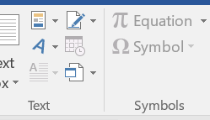

- Once choosing this feature, you will be prompted with a textbox that allows you to input a name and position title, if applicable, or you can leave it all blank and select “OK”.
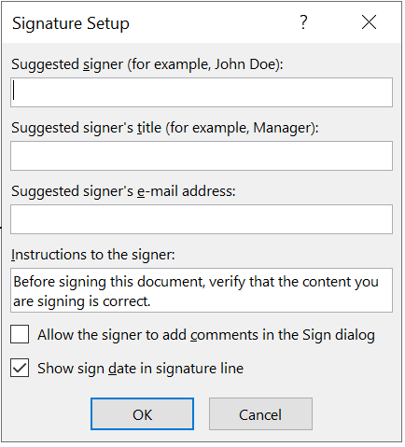

- The feature will place a designated signature line with the details (if any) were added above.
- Right-click on the signature line field, and select the “Sign” option.

- Type your name in the box, or import an image of your signature by clicking the “select image” option.
